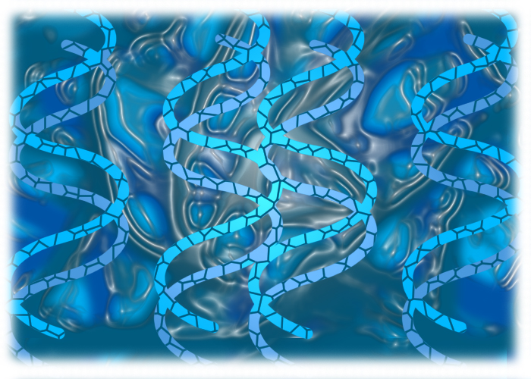
Structure of DNA and RNA – Student Resources
- DNA is the genetic material in all living things. Differentiate between the following:
  - Chromosome

  - Gene

  - Nucleotide

- Three components of a DNA nucleotide
  - Draw the deoxyribose sugar and number the carbons

  - Show which carbon the phosphate group is on

  - Show which carbon the nitrogen base is on

    - List the four nitrogen bases. Circle the purines. Put a box around the pyrimidines.

- DNA is a double stranded molecule. On the diagram below, label hydrogen bonds and phosphodiester bonds. Show how this molecule is antiparallel.
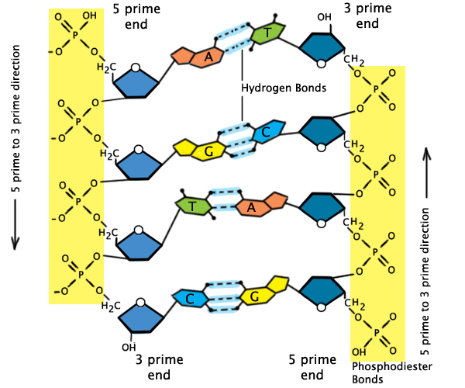
- RNA Structure
  - List two differences between DNA and RNA

  - There are three types of RNA. Define each.
    - mRNA

    - rRNA

    - tRNA

Take Away Questions
- Name the four nitrogen-containing bases found in DNA molecules and identify how they create a base pair.

- If the sequence of one strand of a DNA molecule is 5’-AGCCCCGACTCTATTC-3’, what is the sequence of the complementary strand?

- Provide at least three important differences between DNA and RNA.

